**Redbus Data Scraping with Selenium & Dynamic Filtering using Streamlit**

This documentation outlines the process for scraping bus data from the Redbus website, storing it in a MySQL database, and creating a Streamlit application for data filtering and analysis. The project involves the following key components:

1. **Web Scraping using Selenium**: Automating the browser to scrape data from the Redbus website.
2. **Database Interaction**: Using MySQL to store the scraped data.
3. **Streamlit Application**: Creating an interactive application to filter and analyse the data.

**Prerequisites**

* Python 3.x
* Selenium
* MySQL
* Streamlit
* WebDriver for the browser (Chrome Driver for Google Chrome)

**Setup Instructions**

1. Install Dependencies

Installed the required Python packages using pip:

pip install selenium mysql-connector-python streamlit

1. MySQL Database Setup

Created a MySQL database named Redbus and a table named bus_routes using the following SQL script:

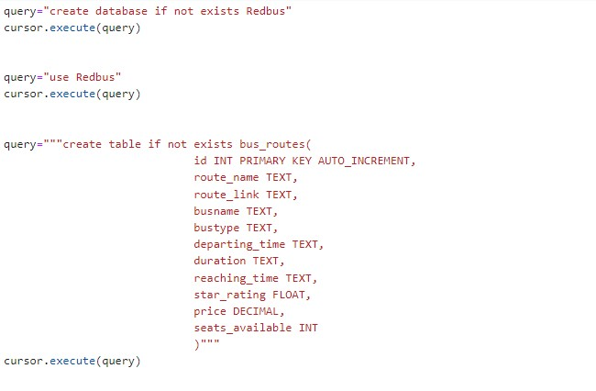

**Code Explanation**

Database Connection

The **get_database_connection** function establishes a connection to the MySQL database.

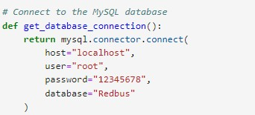

**Creating the Table**

The **create_table** function creates the bus_routes table if it does not already exist.

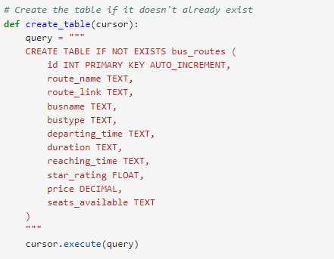

**Initializing the WebDriver**

The **get_driver** function initializes and returns a Selenium WebDriver instance.

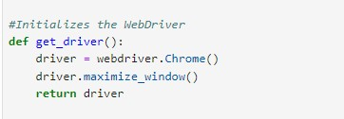

**Scraping Bus Routes and Links**

The **scrape_current_page** function scrolls through the current page to load all bus routes and extracts the route names and links.

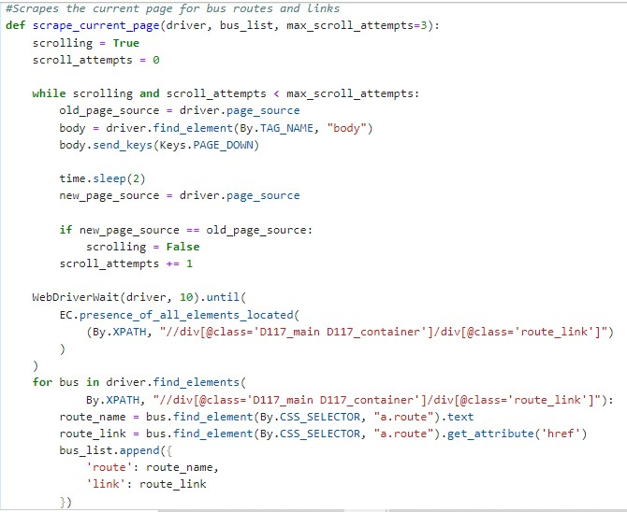

**Clicking the Next Page Button**

The **click_next_page** function navigates to the next page of bus routes.

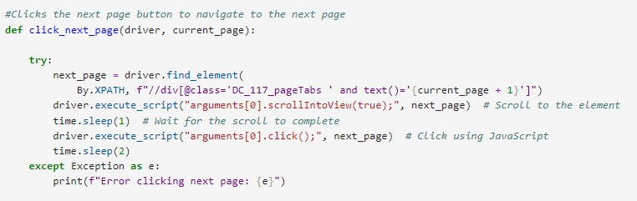

**Scraping Bus Details**

The **scrape_bus_details** function extracts detailed information about each bus on the route.

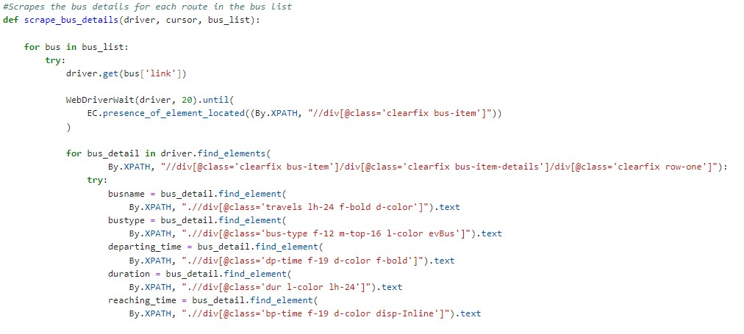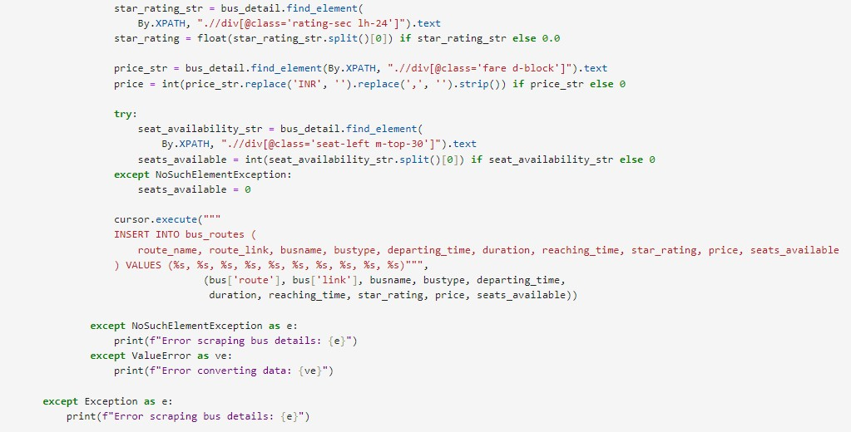

**Main Function**

The main function manages the entire process, from initializing the database and WebDriver to scraping data and inserting it into the database.

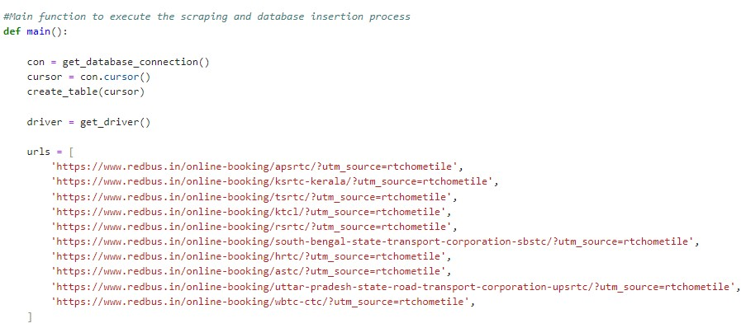

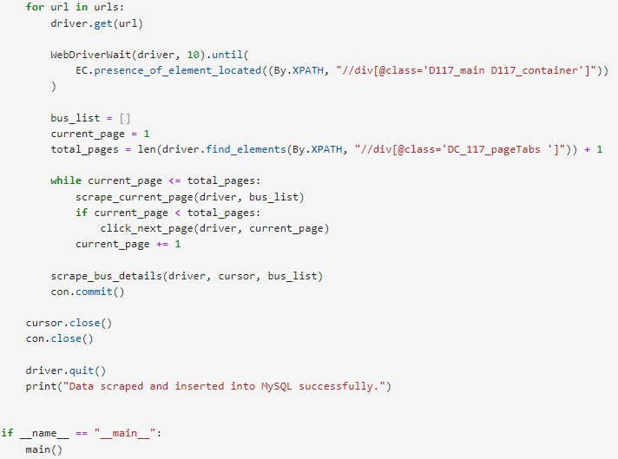

**Technical Tags:**

* Web Scraping
* Selenium
* Streamlit
* SQL
* Data Analysis
* Python
* Interactive Application

**Running the Script**

To run the script, executed the following command terminal:

python scrap.py

**Streamlit Application**

Created a streamlit.py file for the Streamlit application:

**Data Analysis/Filtering using Streamlit:**

Used SQL queries to retrieved and filtered data based on user inputs.

Used Streamlit to allow users to interact with and filter the data through the application.

**Streamlit Application:**

The Streamlit application to display and filter the scraped data.

Implemented various filters such as bustype, route, price range, star rating, availability.

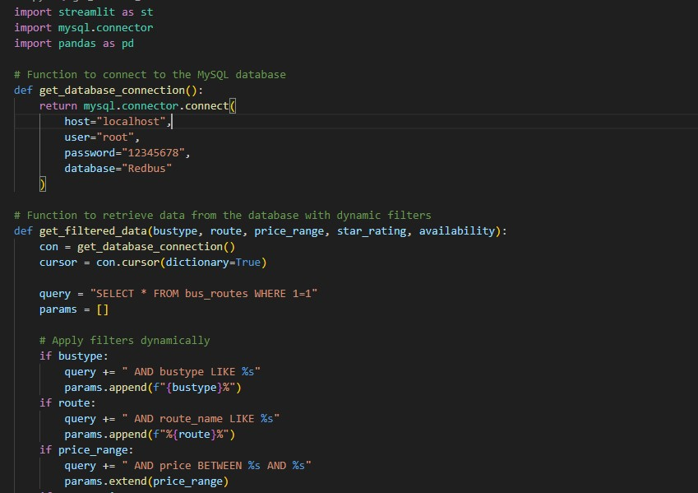

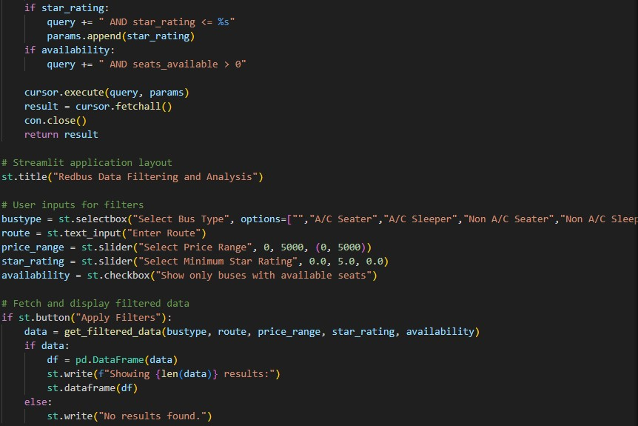

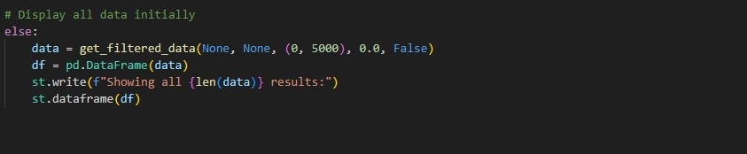

**Database Schema:**

**Table Name: bus_routes**

**Primary Key:** To ensure each record is unique, an auto-incrementing primary key (id) is used.

|  |  |  |
| --- | --- | --- |
| **Column Name** | **Data Type** | **Description** |
| id | INT | Primary Key (Auto-increment) |
| route_name | TEXT | Bus Route information for each state transport |
| route_link | TEXT | Link to the route details |
| busname | TEXT | Name of the bus |
| bustype | TEXT | Type of the bus |
| departing_time | TEXT | Departure time |
| duration | TEXT | Duration of the journey |
| reaching_time | TEXT | Arrival time |
| star_rating | FLOAT | Rating of the bus |
| price | DECIMAL | Price of the ticket |
| seats_available | INT | Number of seats available |

GitHub Link:

https://github.com/vishnupriya08-hub/redbus-data-scraping